* Due to “Request failed because of network connection” error, I’m not able to inspect the payment page in BestBuy project.
* For the first time the page occurs. But after that, the payment page didn’t open due to the above mentioned error.
* So, please consider this website issue and I have validated “CheckOut Page” as a final page.( Order placed)

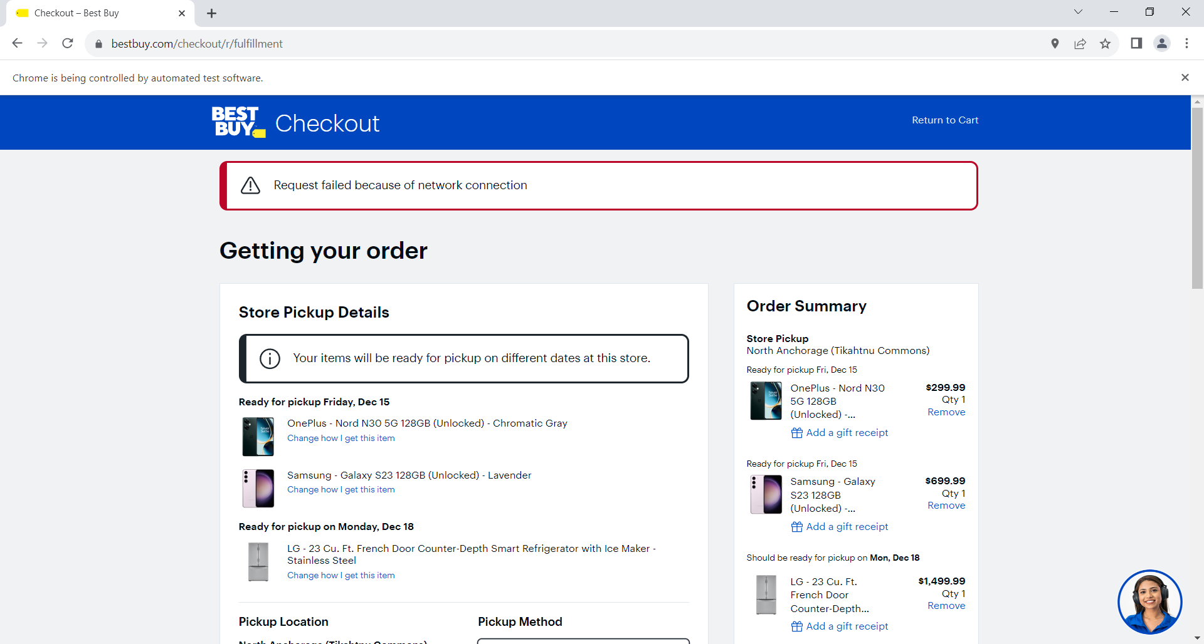Screenshot for proof :